
Final Project Paper
Timothy Victori

Timothy Victori
ENGINEERING DEPARTMENT ARIZONA STATE UNIVERSITY
IFT320: Managing the Cloud
Rahul Kashy
May 2, 2025

Applied Supercomputing Users (ASU) to keep up with its ever growing infrastructure capacity requirements needs to migrate to the cloud. Our requirements consist of the following:
- 20 Databases (Microsoft SQL) Windows servers with 64GB of RAM and 4 CPU cores each
  - A on-Demand instance would cost approximately $1898.72 a month while you can save by introducing Standard Reserved instances at $1444.03 a month
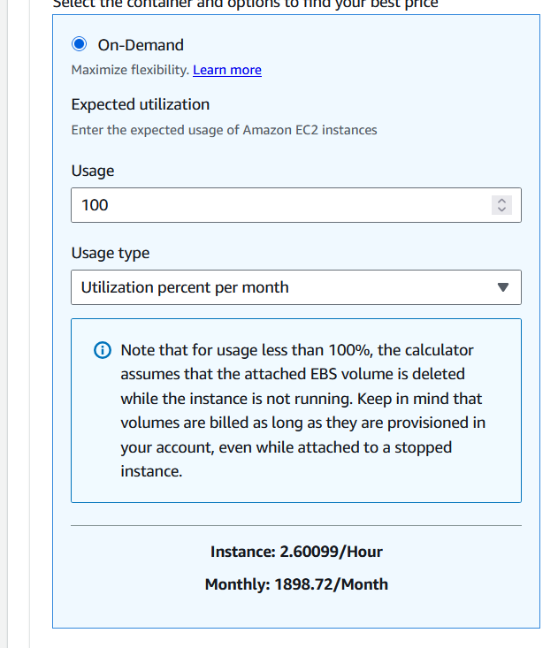
Figure 1: On demand pricing for 20 Microsoft Server instances with MySQL
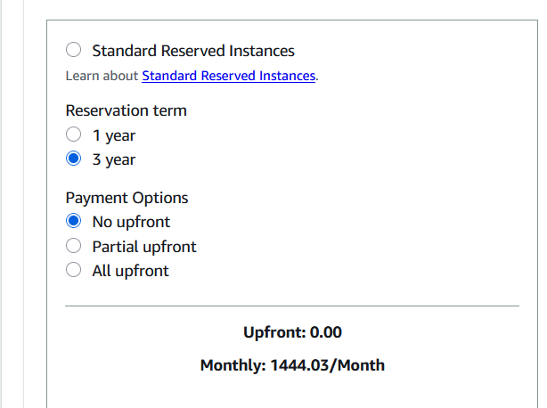
Figure 2: Monthly costs for standard Reserved instances

- 200 non-database Linux servers with 8GB of RAM and 2 CPU cores each
  - .

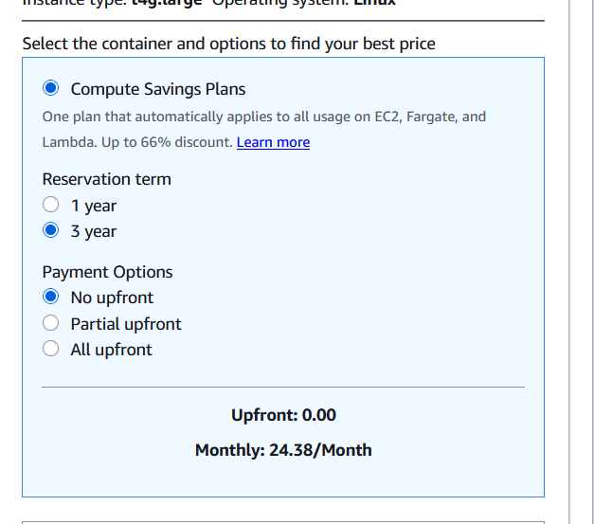
Figure 3: Amazon EC2 Calculator Showing Monthly Costs for 200 non-databased Linux servers for a 3 year period
- 25TB of S3 Storage
  - Assuming we have frequent access to the data here due to application storage assuming approximately 100,000,000 requests per month comes out to $589.30 for S3 Standard storage.(Amazon Web Services, 2025, Secure Storage).
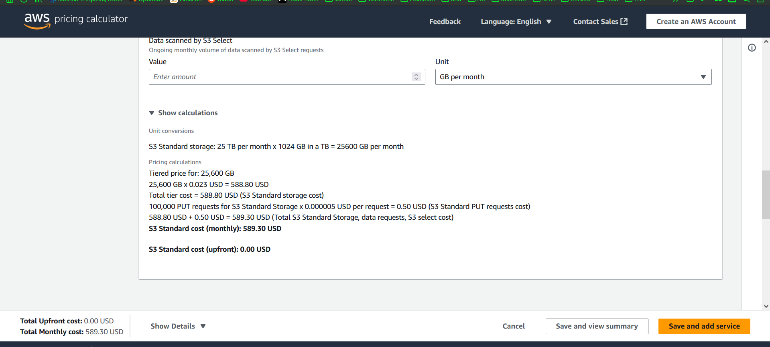
Figure 4: AWS Calculations using AWS Pricing Calculator for 25TB of S3 Standard Storage with 100k requests
- 10TB of EBS storage
  - The EBS storage for OS use would require a total monthly cost of approximately $1024.00 for the storage and if we are doing 2 snapshots a day to decrease the impact of corrupt data or system failures we end up with a $541.91 snapshot cost totaling to a $1565.91 estimated cost for EBS storage (Amazon Web Services, 2025).
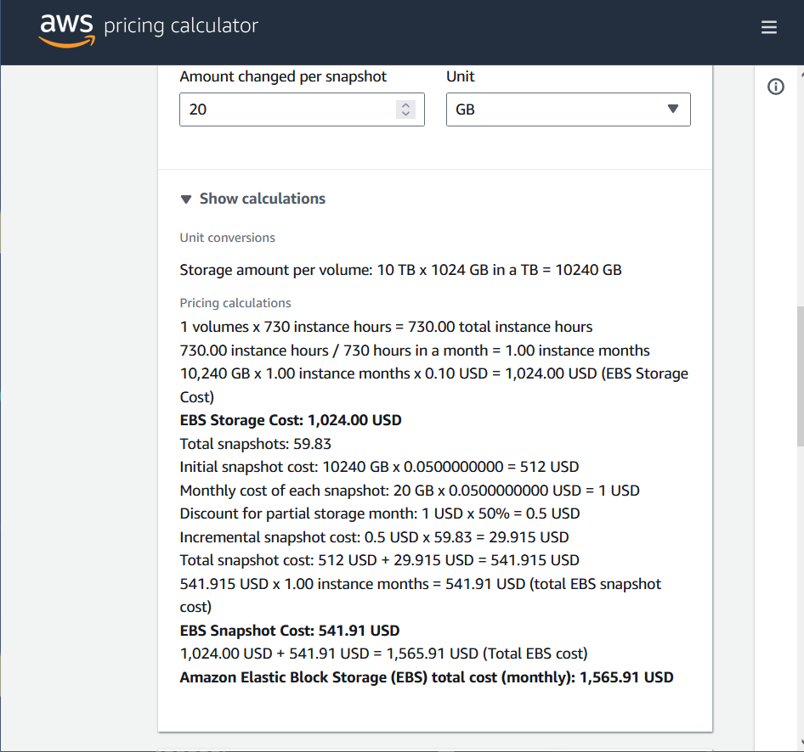
Figure 5: AWS pricing calculator estimate for the EBS storage required for 10TB of data with snapshots.
To decrease our overall costs AWS offers different types of storage for S3 instances. S3 Standard is used for data we need to consistently and constantly access and is the more expensive storage option. When data is only going to be accessed every once in a while, S3 infrequent Access tier is better suited for the data as while requests are slightly more expensive the storage costs are significantly decreased. The final and cheapest storage tier is Glacier storage which takes up to 12 hours to retrieve the data (Amazon, 2025). Glacier is best used for backups and data that is only needed a few times a year. Placing data in the appropriate tiers can reduce costs significantly.
Paying upfront for the EC2 instances can decrease the costs as by paying all upfront for our Linux instances for example we have an $81.68 difference. Paying for a 3-year plan instead of a 1-year plan also ends up being cheaper overall. The instance type used in calculation was the cheapest based on the specifications given but based on real volume other instance options may end up actually being cheaper for the company overall. In addition Standard Reserved instances can decrease the price further by making the instances cheaper.
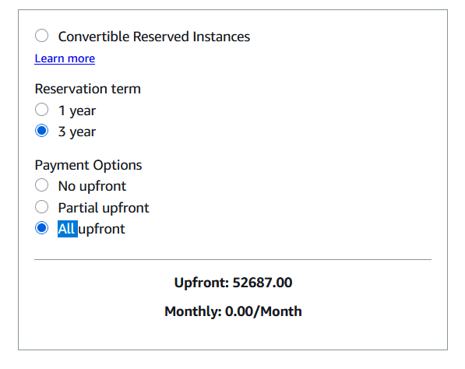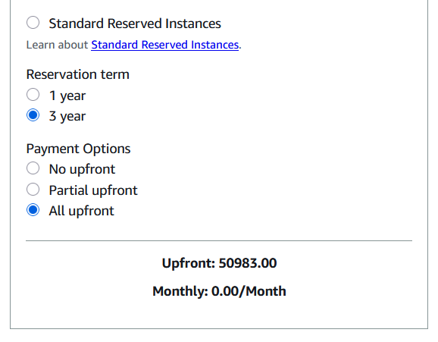
Figures 6 & 7: Upfront costs for the Microsoft server instances in different instance types.

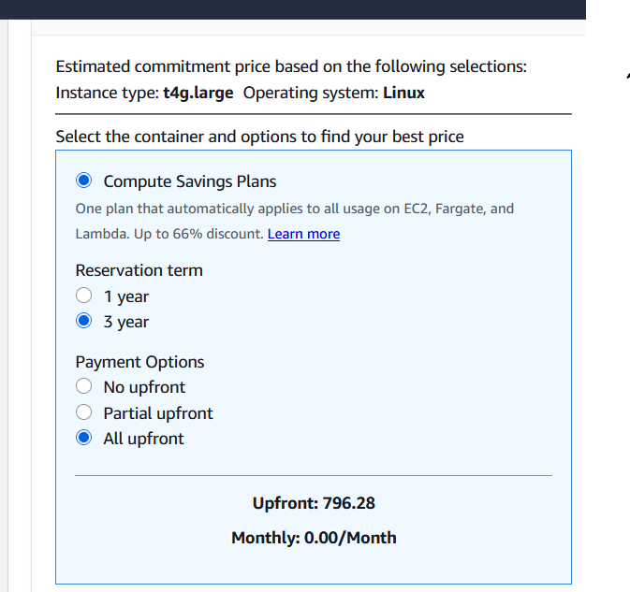
Figure 8: Amazon EC2 Calculator Showing Upfront Costs for 200 non-databased Linux servers for a 3 year period
The process of migrating the ASU infrastructure to a cloud-based platform involves several steps A strategic plan is required to get the most out of our migration to the cloud (Kale, 2015, p.425). First you must plan for migration and prepare your systems for the upcoming migration. You have to start with finding our why you are migrating (Perry, 2021). In our case we are migrating because of cost and scaling issues. When the plan for migration is finalized with goals and you have determined what services to migrate where you can move on to moving your apps to the cloud. According to the AWS documentation, it is recommended to retire old infrastructure when migrating it to the cloud (Amazon, n.d,). Amazon has the 7 Rs as ways to migrate. These include, Retire, retain, rehost, relocate, repurchase, replatform, refactor or re-architect. Retire means to retire the infrastructure that is made redundant by cloud computing. Retain refers to what information you need to keep off cloud for either security, financial, or practicality reasons. Rehostr refers to moving the machine power to the cloud. Relocate refers to moving the data to the cloud. Replatform refers to moving the entire platform and is very resource intensive. Refactor or re-architect refers to completely redoing your infrastructure from the ground up on the cloud which should be a last resort (Amazon n.d.).
Overall the company should move most of its resources to the cloud to help with cost and scalability issues.

Sources:
Kale, V. (2015). Guide to cloud computing for business and technology managers: From distributed computing to cloudware applications, (1st ed.). Boca Raton, FL: CRC Press.
Amazon Web Services. (2025). AWS Pricing Calculator. https://calculator.aws/#/createCalculator/S3
Amazon. (2025). Secure storage - amazon S3 Glacier Storage Classes - AWS. https://aws.amazon.com/s3/storage-classes/glacier/
Amazon. (n.d.). About the migration strategies - AWS prescriptive guidance. https://docs.aws.amazon.com/prescriptive-guidance/latest/large-migration-guide/migration-strategies.html
Perry, Y. (2021). AWS migration: Migrating to AWS in 5 steps | netapp. https://www.netapp.com/learn/aws-migration-5-key-challenges-and-solutions/

